Problem Description of the Tango device Lenovo PB2-690M (Lenovo Phab2 Pro)
Zoutao WEN
Haute ecole d’ingenierie et d’architecture Fribourg

Problem

Description
In the project “Indoor localization and augmented reality with a google Tango device”, we use Lenovo PB2-690M (Lenovo Phab2 Pro) as the Tango device. With it, we mainly do two procedures for indoor localization:
- Firstly, we explore the zone. As the following figure shows, after the trace of exploration, we get a file (Area Description File, ADF) which records all the information of the zone.
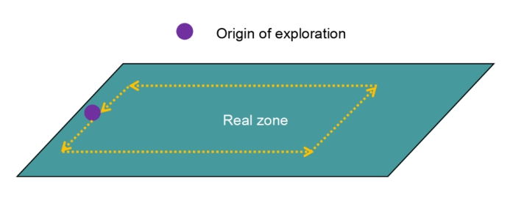
Figure 1 The way that we explore the zone
- Then, we localize in this zone. With the file mentioned above, the device is able to localized itself in this zone and also compare the coordinates in the file and in the real zone. The official application will give the information shown in the following figure.
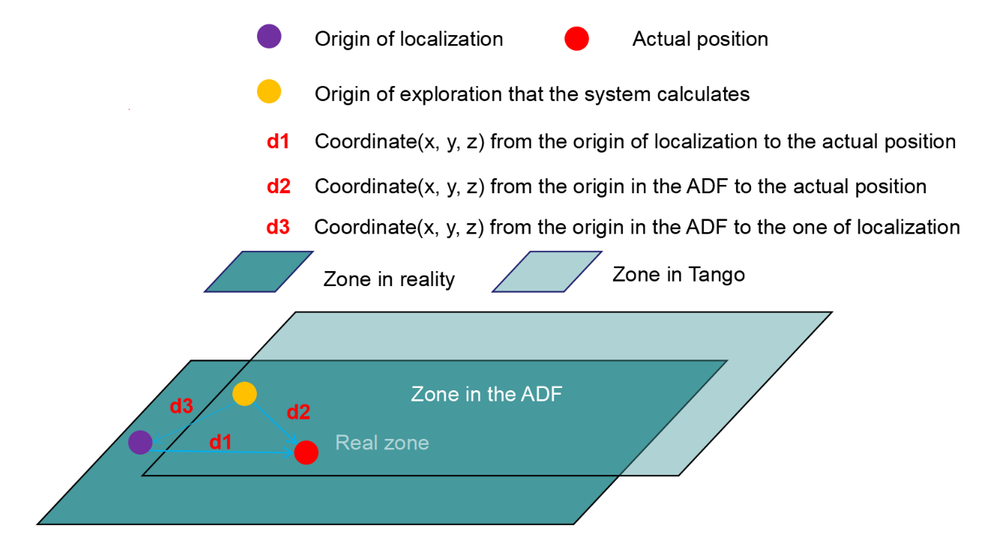
Figure 2 The signification of the coordinates
The application we use is an official example “hello_area_description” that can be found in https://github.com/googlesamples/tango-examples-java/archive/master.zip. You can also find this application in the attached file.
In the application, when exploring the zone, we choose the “Learning mode (on)” and keep “Load ADF (off)”. And then we walk in a loop to explore and save the ADF. When localizing the zone, we turn both “Learning mode” and “Load ADF” on. Then we follow the same trace to wait for the localization.
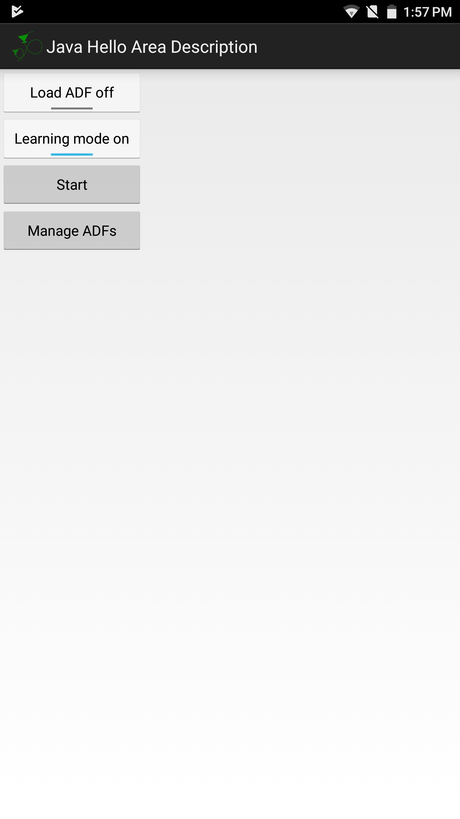
Figure 3 The choices when exploring the zone
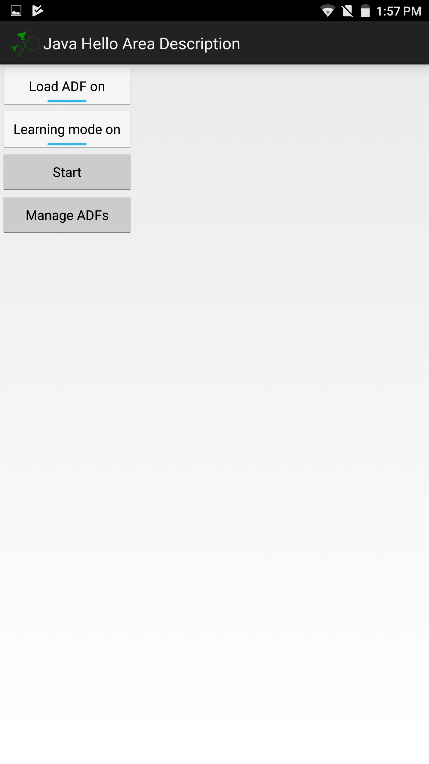
Figure 4 The choices when localizing the zone

Normal situation
In the normal situation, the device can successfully localize itself in the same zone and give the proper results.
We have done the test two weeks before (around July 5th, 2017). The result was good. It gave the correct coordinates (p means position with three dimensions and q means rotation using four Quaternion items to measure).
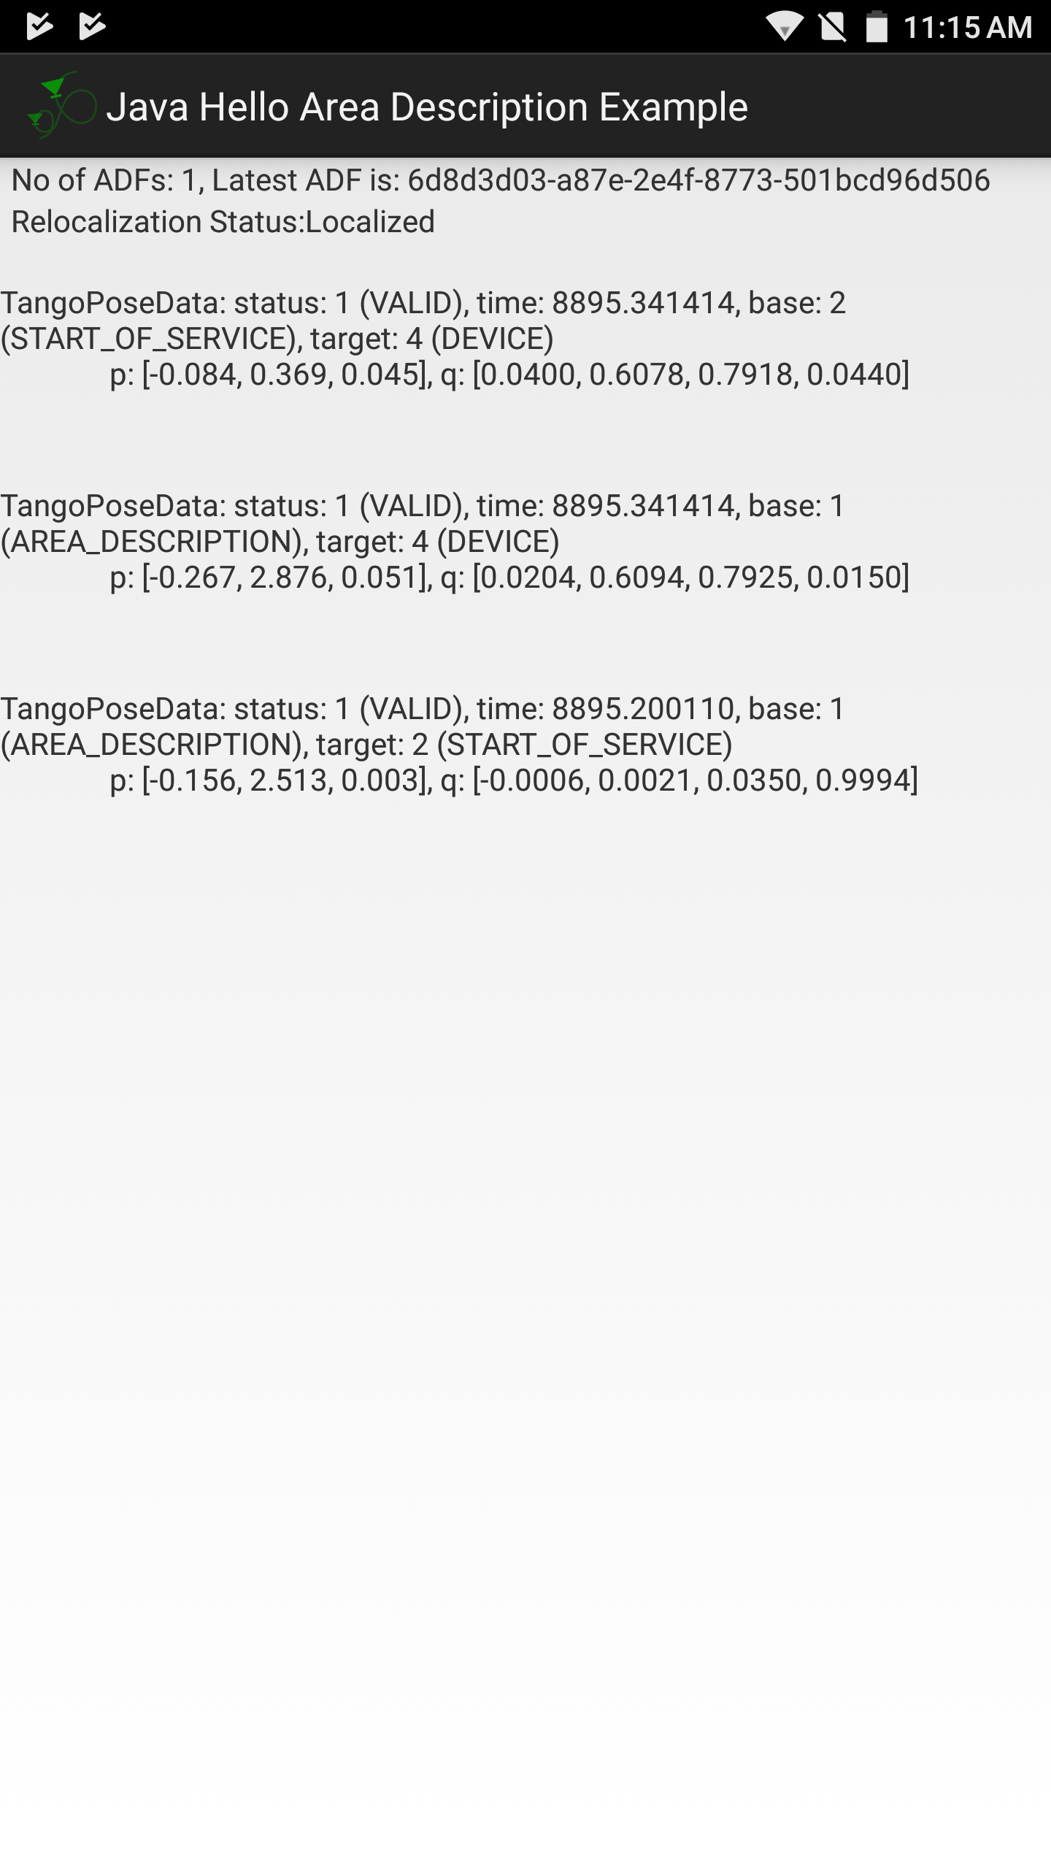
Figure 5 Correct results in normal situation

Actual situation
We also do a test in the date July 19th, 2017 to clarify that in actual situation the device is no longer well functioned.
We have followed the same procedure mentioned above and the results show as followed. Firstly, the second coordinate (from the origin in the ADF to the actual position) is too close to the first one. But for one hand we don’t begin from the same point for the exploration and the localization. For another hand, the two coordinates remain the same even if we keep walking in no matter which direction, which proves that it is not the case of isosceles triangle.
Secondly, the third coordinate do not show the real situation (the origins is not the same). Even when we keep walking, it remains unchanged.
Thirdly, when we branch the device to the computer, the Logcat of Android Studio don’t give any error.
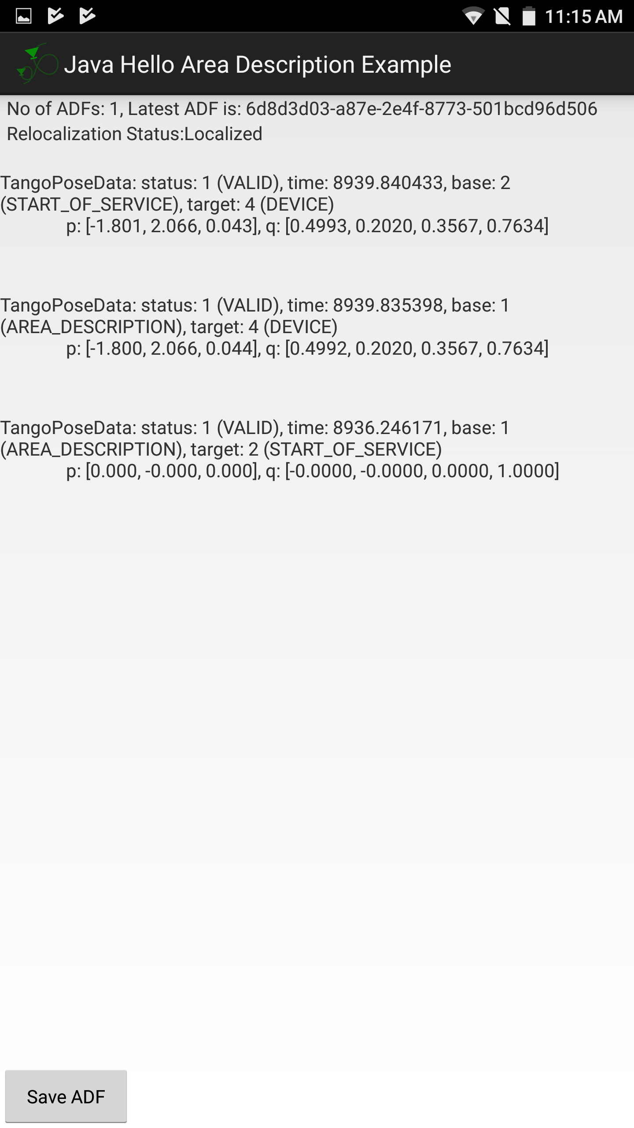
Figure 6 Wrong results in actual situation

Tests

Possible points where this problem occurs
- The logic fault of the application
- The error of Tango core or Tango library
- The problem of the computer
- The problem of the device

The tests show no fault in application
First, we have re-examined the codes that we use. The codes are the newest updated and it is uploaded by Google Tango, which means that it cannot be wrong. Then, we check the inner logic of the problem with the tutor in the official website. It shows no wrong in the logic. The Android Studio shows no error, which shows no wrong for the program.

The tests show no effect on Tango core nor Tango library
The Tango Core in Google Play, which is a must for Tango Application, is updated on Jun 26th, 2017. This means that the Tango Core has already been updated and the application worked well (Chapter 1.2).
For the Tango library, we have tested all the exist versions (1.50 to 1.55). And none of it works properly.

The tests show no effect on computer
We also considered that the Android Studio may occur mistakes. So we change to a Linux computer to download the application. The result remains wrong. For another time, we use another Win10 computer and the result remains the same.

The tests on device
We have no choice to believe that the problem occurs on the device itself.
We have done the factory reset of the device. The result does not change.
The last method that we consider is that we flash a new official ROM. However, we don’t dare to do this. For one hand, we cannot find an official ROM from any official website of Lenovo and the only ROM that seems available is provided in a Russian website. For another hand, if the ROM fails, we lost the warranty as well. Furthermore, if the problem occurs in the hardware, flashing ROM cannot solve the problem.

Result
As a result, we conclude that the problem occurs not in the application nor in the Tango Service (Tango Core and Tango Library). It is highly possible that it occurs on the device Lenovo PB2-690M (Lenovo Phab2 Pro). Therefore, we consider that the device should be carefully examined.

https://developers.google.com/tango/overview/area-learning
http://lenovo-forums.ru/topic/22916-proshivka-pb2-690m_s200100_170228/

